

YEAR: 7
2023
SUBJECT: Science
ANSWER KEY

TEST: Ecosystems
TIME: 50 minutes
QUESTIONS: 10 Multiple Choice (10 marks)
Short Answer (37 marks)
TOTAL MARKS: 47 marks

DO NOT WRITE ON OR MARK THIS PAPER
SECTION ONE—MULTIPLE CHOICE (10 marks)

This section has 10 questions. Answer all questions on the separate Multiple-choice Answer Sheet provided.

- Plants are examples of:
  - decomposers
  - carnivores
  - producers
  - consumers

- Bacteria and fungi belong to an ecosystem group called:
  - herbivores
  - decomposers
  - plants
  - composers

- Which of the following is the best definition for an omnivore?
  - an organism that feeds on dead things
  - an animal that eats plants only
  - an organism that eats both plants and animals
  - an organism that eats animals

- What do the arrows in a food web and food chain represent?
  - the organism that eats the other
  - the flow of energy
  - the organism that is eaten by the other
  - the herbivores in the system

- As you move up the food web:
  - the number of organisms stays the same, but the size decreases
  - the number of organisms increase
  - the number of organisms decreases
  - the number of organisms stays the same, but the size increases

- Select from the options below why the European wasp was introduced to Australia.
  - to help pollinate
  - to control the population of insects
  - they were accidentally introduced
  - for the cane toad to eat

Use the food web below to answer questions 7-9.

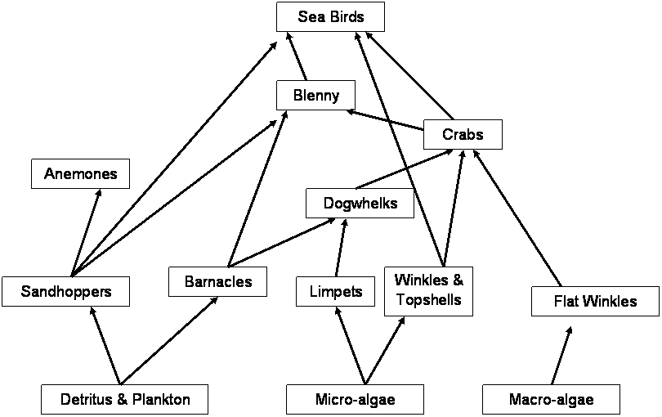

- How many primary consumers are in the food web?
  - 2
  - 5
  - 3
  - 4

- How many organisms are both secondary and tertiary consumers in this food web?
  - 3
  - 2
  - 5
  - 4

- If decomposers were removed from this food web:
  - nutrients would not be returned to the soil in order for producers to grow healthy
  - waste and dead organisms would pile up
  - there would be a break down in the flow of energy
  - all of the above

- Which of the following is not an introduced species?
  - cane toad
  - rabbit
  - feral cat
  - kangaroo

END OF MULTIPLE CHOICE SECTION
Please continue with short answer section in the answer book.

SEMESTER TWO 2023
Ecosystems Test:
ANSWER BOOKLET

NAME:
FORM: DATE:

I CAN STATEMENT | QUESTIONS
MUST  Makes predictions about the effects of environmental change on directly-connected organisms within a food web. | 1, 2, 3, 4, 6, 10, 11, 12, 13, 14, 15, 16, 17, 20, 22, 23 & 25
SHOULD  Makes predictions about and explains the effect of environmental change on populations within the food web. | 5, 7, 8, 18, 20, 22, 23 & 24
COULD  Makes predictions about and explains the effect of environmental change on the entire food web or community. | 9, 19, 20 & 21

Multiple Choice Short Answer Total

/37

/10

/47

SECTION ONE: Multiple choice answers
Cross (X) through the correct answer.

1 | a | b | X | d
2 | a | X | c | d
3 | a | b | X | d
4 | a | X | c | d
5 | a | b | X | d
6 | X | b | c | d
7 | a | X | c | d
8 | X | b | c | d
9 | a | b | c | X
10 | a | b | c | X

SECTION TWO: Short Answer (34 marks)

Answer the questions in the spaces provided.

- What is the difference between a food web and a food chain? (1 mark)
Food chain shows one path of energy (0.5 mark)
Food web shows how organisms in in an ecosystem interact (0.5 mark)

- Classify the following list as either a producer or consumer. (4 marks)
Organism | Producer or consumer?
Cat | Consumer
Magpie | Consumer
Rose | Producer
Eucalypt | Producer
Sparrow | Consumer
Worm | Consumer
Ant | Consumer
Rotting tree log | Producer

- What is the primary source of energy for all life on earth? (1 mark)
The sun (1 mark)

- Provide a definition for the following organisms in an ecosystem. (3 marks)
1 mark for Decomposer: organism which will breakdown organic material (no mark if no mention of organic in their definition)
1 mark for Predator: animals which will kill and gain energy from eating other animals (no mark if no mention of kill in their definition).
1 mark for Heterotroph: organisms which gain energy from consuming/eating other organisms.

- Draw a line clearly linking the term to the definition. (3 marks)
(0.5 mark for each correct answer)

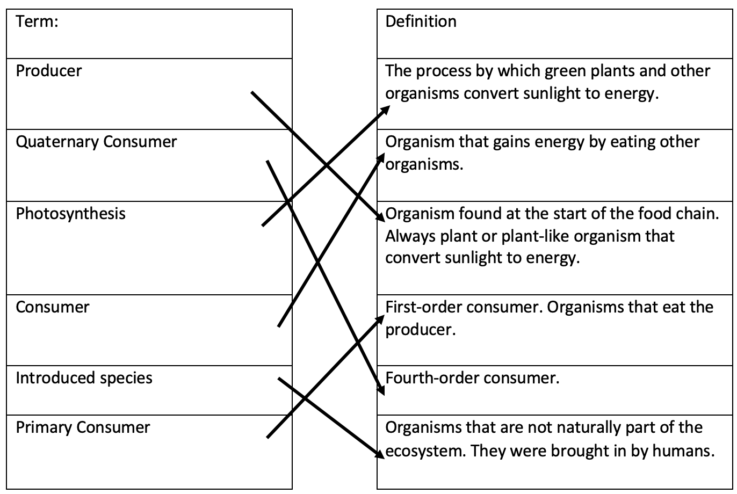

- Construct a food chain from the following information: (3 marks)
A shark swims through the ocean in search of seals. In turn, seals search for large fish. Large fish have a diet of smaller fish. Floating in the water are millions of plankton. These are microscopic producer organisms that provide food for smaller fish and other herbivorous animals in the ocean.
FOOD CHAIN
Plankton -> small fish -> large fish -> seals -> shark
0.5 mark for each animal in the correct place, 0.5 mark for arrows.

- Use the following information to construct a food web in the box below: (5 marks)
Algae (producer)  Snail (eats algae) | Small fish (eats algae and snails)  Water beetle (eats small fish) | Frog (eats beetles)  Snake (eats beetles and frogs)

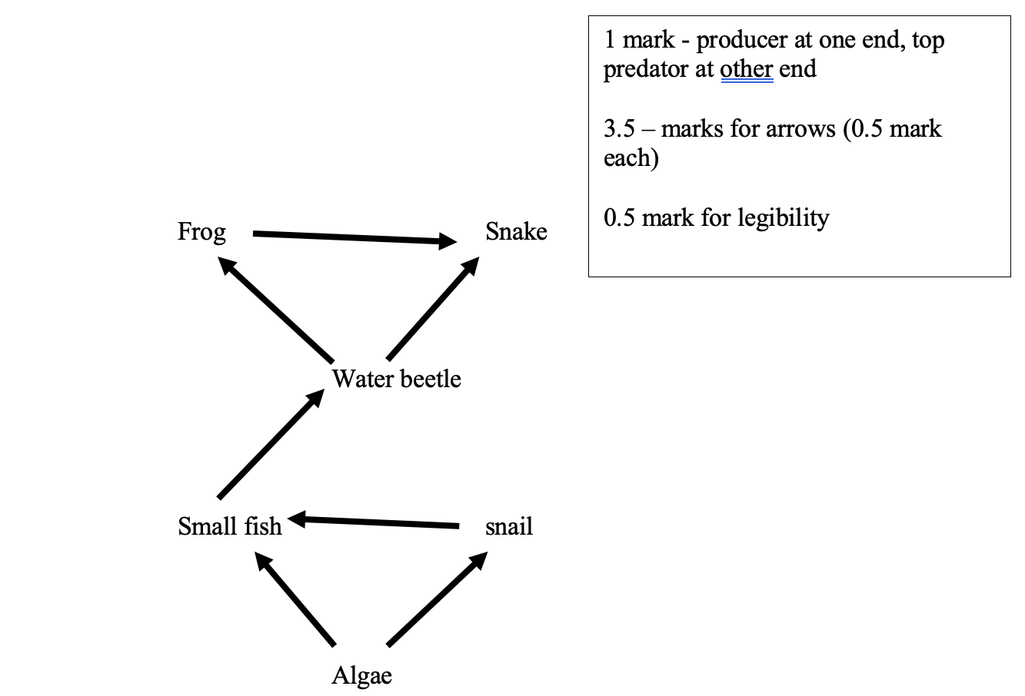

- Examine the food web below: (6 marks)

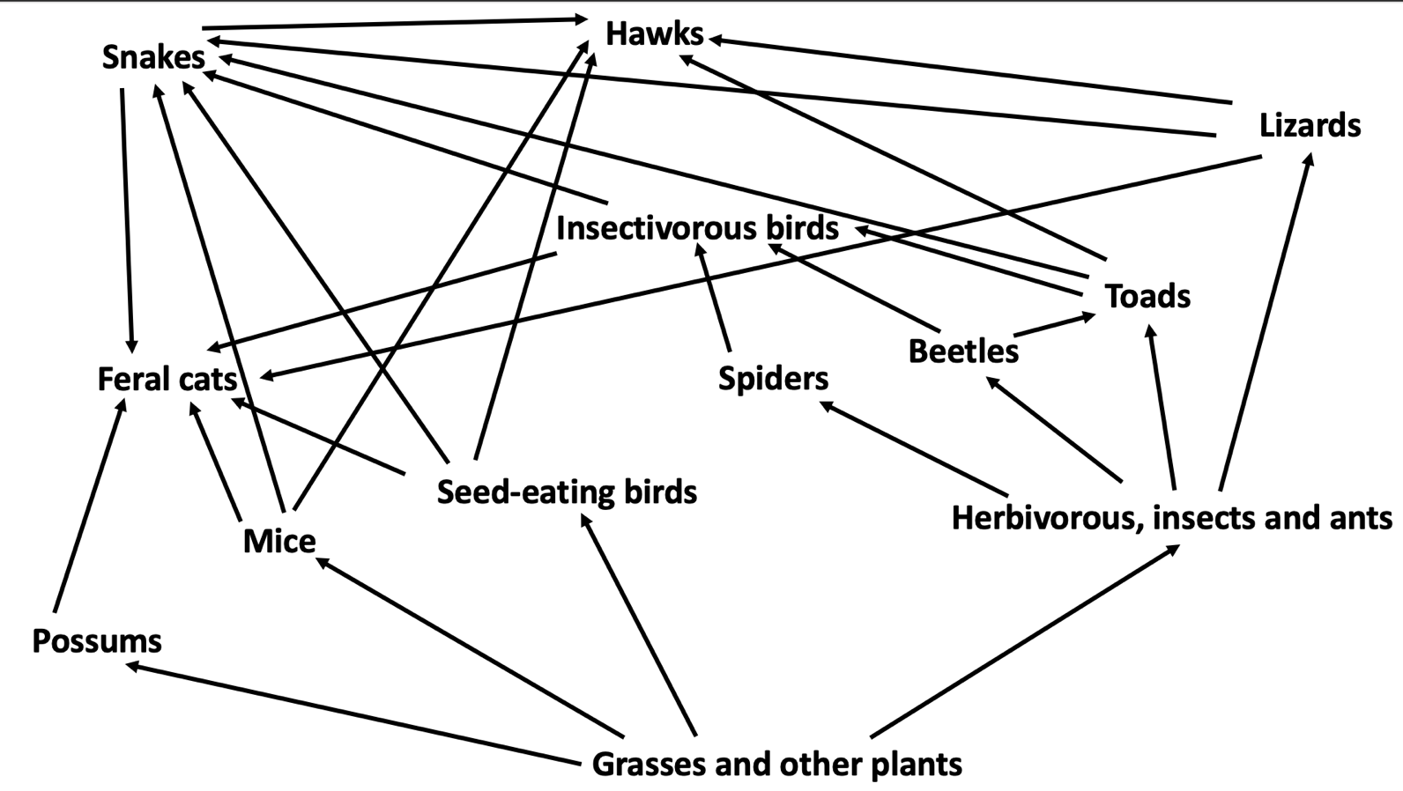

- Identify the producer: _____________________________________________________________
Grasses and other plants (1 mark)

- Identify the top order consumers: ___________________________________________________
Hawks and feral cat (1 mark )

- Complete the food chain so that it ends with a hawk:
Plants ---> ____________ ---> _____________ ---> ___________
Any reasonable answer (1 mark max, ½ mark if one correct)
- Write out a different food chain from the one above. Include a producer, and three consumers.

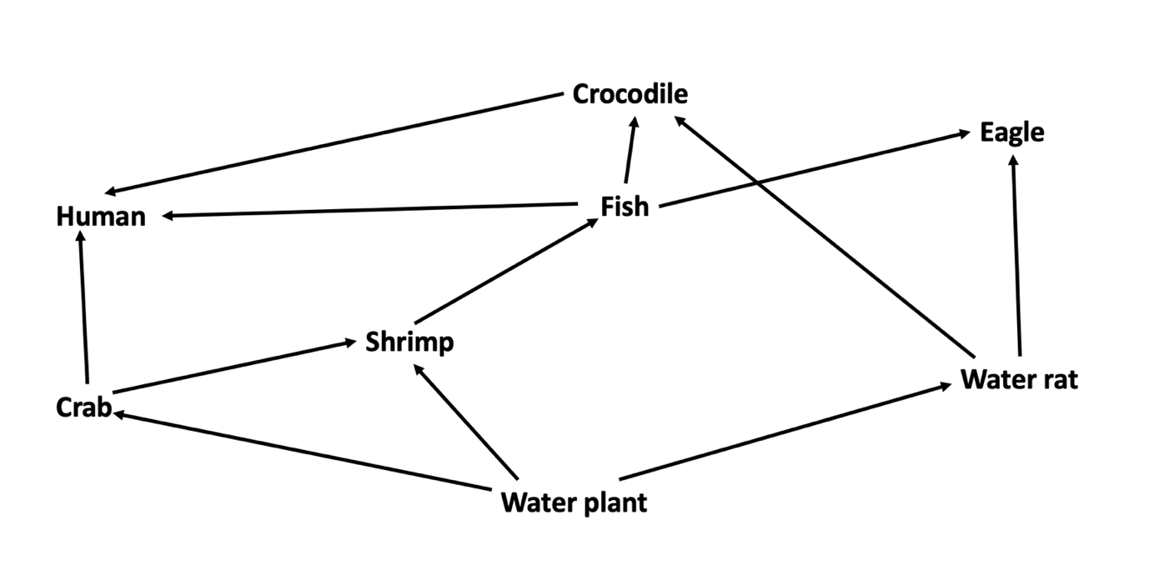
Any reasonable answer (2 marks)

- Use the food web above to complete the following questions. (2 marks)

  - Propose what would happen to the eagle population if the water plant population was significantly reduced due to rise in water temperature.
Fish population would increase (1 mark)
Any reasonable answer
  - Justify your proposal above.

The predator of the fish would decrease (1 mark)
Any reasonable answer

- This food web represents a freshwater creek ecosystem.
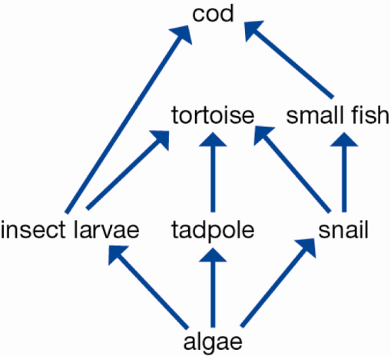

  - Explain why this community could not survive without the algae. (1 mark)
______________________________________________________________________________________________________________________________________________________
Without the algae there would be not energy entering the food web (1 mark)
  - Draw the decomposer on the food web. (1 mark)

1 mark for drawing reasonable organism which can decompose

- Using an example, describe how loss of an organism from an ecosystem can have negative effects. (3 marks)
_______________________________________________________________________________________________________________________________________________________________________________________________________________________________________________________________________________________________________________________________________________________________________________________
Example (1 mark)
Negative effects (1 mark each, Max 2 marks)

- List four ways in which humans damage ecosystems. (4 marks)

  - ______________________________________________________________________________________________________________________________________________________
  - ______________________________________________________________________________________________________________________________________________________
  - ______________________________________________________________________________________________________________________________________________________
  - ______________________________________________________________________________________________________________________________________________________
1 mark for any of the 4:
Deforestation, land degradation, pollution, urbanisation, agricultural and introduced species.

END OF TEST
Please go back and check your work!

